Job Description
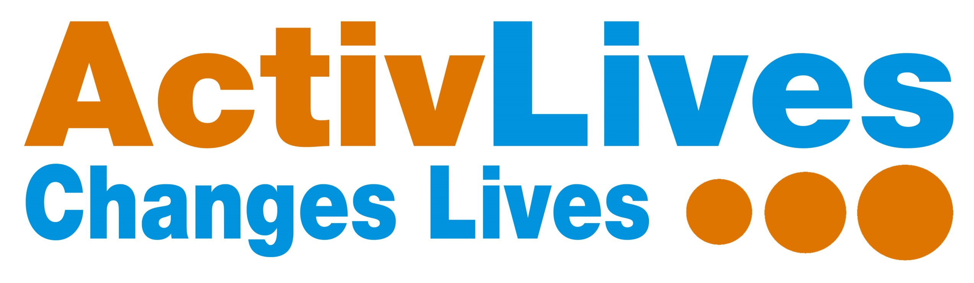
Job Title: ReBalance Programme – Fitness Co-ordinator Hours: 15 hours per week

Reporting to: CEO Base: Ipswich and East Suffolk

Job Purpose

To engage with individuals and local communities in East Suffolk to proactively promote the ActivLives ReBalance Programme – this includes Keep on Moving Falls Prevention exercise classes, Strength and Balance OTAGO exercise classes and Breathe Fit exercise classes. Overall responsibility for the successful and safe delivery of these activity exercise sessions, aimed at older adults who are at risk of falls, or who have long term health conditions, increasing participation and achieving all project outcomes through effective use of resource.

To contribute to the achievement of the ActivLives vision; “To create stronger, healthier communities, reduce health inequalities and provide new learning to enable people to live full and active lives.”

Areas of Responsibility
Project Management
- Responsible for the successful delivery of Keep on Moving Falls Prevention sessions in Leiston and Saxmundham, Strength and Balance OTAGO sessions in Saxmundham and Breathe Fit sessions in Leiston
- Working closely with the CEO and other members of the ReBalance team, support the development of both existing and any new exercise sessions that may be introduced
- Assist with any taster sessions to showcase activities, and where there is sufficient demand, follow these up by establishing new on-going regular sessions
- Ensure that community venues are suitable for the type of activity, particularly that they are accessible in order to encourage the target audience to attend, and also making sure that the relevant policies and procedures are in place with risk assessments regularly updated
- To maintain clear and concise records as necessary and to collect information to help produce quarterly and annual reports
- To gather the required evaluation data, through referrals, registration, attendance registers, assessments, feedback, case studies and photos to track and measure the progress of individuals and the impact made

Business Development and Promotion
- Develop existing sessions to attract new members, helping to ensure the longer term financial viability of the sessions
- Contribute ideas and suggestions, and identify new opportunities to support the development and sustainability of the ReBalance Programme, including providing information for future funding bids as and when required
- Develop good working relationships with partner organisations and be an ambassador of ActivLives, proactively promoting and increasing the awareness of the ActivLives brand and its services at any meetings or events you may attend

People Management
- As and when required, recruit volunteers to help support activity sessions with tasks such as taking the register and collecting money, making teas and coffees, and supporting participants who need help during the session
- Support volunteers, and ensure that they are aware of ActivLives key Policies & Procedures, Health & Safety etc and assist the CEO in co-ordinating any training required to enable them to perform at the highest level and achieve their full potential
- Lead by example by demonstrating exceptional customer service, and promote a fun working environment, where freelance instructors and volunteers feel valued

Health and Safety
- Ensure that all exercise sessions meet with Health and Safety standards and are compliant with ActivLives Health and Safety policies and procedures, to ensure the well-being of members and volunteers
- Ensure that risk assessments are completed for each community venue and safe working practices are being followed
- Ensure that all equipment used is in working order and the surrounding environment is safe

Personal Development
- To be fully conversant with policies including Equal Opportunities and Diversity, Children, Young People and Adults at Risk Safeguarding, Health and Safety, First Aid and Volunteering
- To undertake relevant continuing professional development training in order to fulfil the duties of your post and to further develop the ReBalance Programme
- Commitment to delivering high quality sessions to meet project outcomes
- Participate in regular support sessions with the CEO
- Effectively contribute to the ActivLives Team and the achievement of the ActivLives vision

Person Specification
Qualifications
- Level 2/3 Accredited Fitness Instructor (essential)
- Chair Based Exercise Instructor (desirable)
- OTAGO Instructor (essential, although training can be provided for the right candidate)
- PSI or other specialist qualifications in working with older people (desirable)

Experience
- Experience of working with and understanding the needs of older people and Functional Fitness (essential)
- Development and delivery of OTAGO Falls Prevention Exercise (OTAGO training is available)
- Experience of working with people with COPD and other respiratory health conditions (desirable)
- Proven success in effectively managing and/or developing projects
- Proven success of delivering and advocating exceptional customer service

Skills & Knowledge
- Exceptional communication skills
- Strong numeracy skills
- Computer literate with a sound knowledge of Microsoft Office, primarily Word, Excel and Outlook
- Experience of managing customer concerns to appropriate resolutions, including conflict resolution skills

Personal Qualities
- Ability to communicate effectively with a variety of people at all levels
- Approachable and able to effectively build rapport with a diverse range of people
- Meticulous attention to detail, high quality completer/finisher
- Resourceful, logical and highly organised, reliable and punctual
- Self-starter, enthusiastic, energetic, flexible and confident
- Tenacious and resilient – able to adapt to change, and good team player
- Able to effectively problem solve
- Flexible approach to working hours and location of work

This job description is not exhaustive and is subject to change from time to time to meet the needs of the organisation.

