
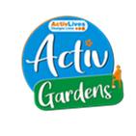
CRESS Pavilion Booking Fees
Community / Groups and Voluntary Organisations
- £23 per hour
- Full day or evening - £115.00
- Full day and evening - £145.00
- Donation for refreshments

Statutory Organisations / Police / Council / MP Surgeries / Corporate
- £25 per hour
- Full day or evening - £125.00
- Full day and evening - £155.00
- Refreshments - 50p per cup
Block bookings by arrangements
Booking timings should include set up
and clear away
ActivLives
A Company Limited by Guarantee registered in England and Wales No. 7672809 Registered Charity No. 1147615

